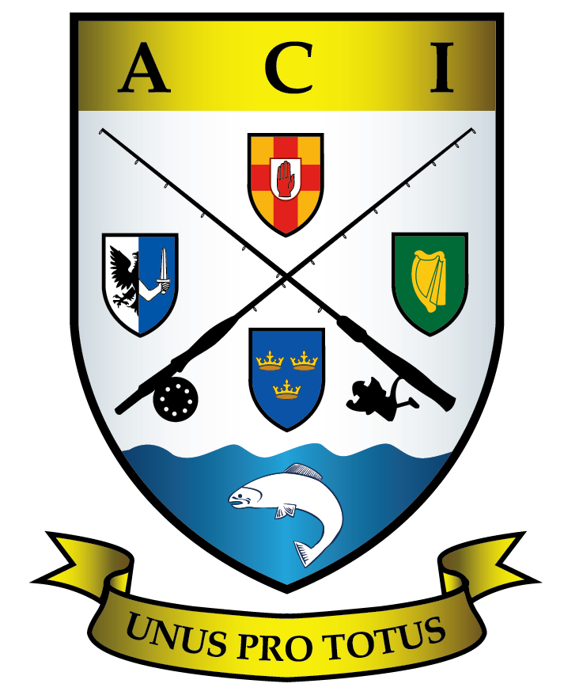 Angling Council Ireland
To Distribution, 15 Apr 2012

Invitation to Attend and Participate in Free CPD Event “Coaching People with Disabilities”

Dear Coach,

The Angling Council of Ireland is holding a free CPD event in Mount Juliet Hotel Kilkenny “Coaching People with disabilities. All introductory level coaches and coach tutors are invited to register for this course. To register please forward your details to your NGB Secretary (NCFFI, IFSA, IFPAC and SSTRAI ) through your club.

This CPD event is organised to train and familiarise coaches in best practice for coaching people with disabilities. It is envisaged that our coaches will be actively involved in the roll out of these events. We have selected Monday 14th of May as a taster day so that people with disabilities may try out a day’s angling with our coaches to see if they might like to take it up as a sport or leisure activity.

The morning session will begin with a powerpoint presentation on coaching people with disabilities. This will be followed by a practical demonstration of tackle assembly and set up for trout angling and a two hour angling session with clients in the afternoon. All tackle and equipment will be supplied on the day. It is estimated that we will have in the region of forty disabled angler clients present, they will be accompanied by their carers. This is an excellent opportunity for you as coaches to practice some of your skills under the supervision of coach tutors and to gain points for your coaching logbook. It is anticipated that the event will conclude around 4PM.

Further details of venue and timings will be made available to those who register. Please register as soon as possible, registration closes on the 10th of May. I hope you can make it, this will be a good opportunity to gain valuable experience, and also it will give you an opportunity to network with the other coaches and tutors. It will prepare you for participation in the ACI programme for coaching people with disabilities during 2012.

We look forward to meeting you on the day.

Best regards

Der Casey
ACI Coach Course Co-ordinator

Der Casey NCO ACI
E-mail dercasey@anglingcouncilireland.ie
Mobile 0860568430 Home 051338532
www.anglingcouncilireland.ie
Distribution: All ACI Introductory level Coaches and Coach Tutors

